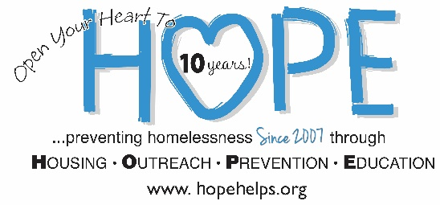
Donor Privacy Policy
HOPE Helps, Inc's mission is to prevent and reduce homelessness in Central Florida by equipping individuals and families to become self-sufficient through Housing, Outreach, Prevention, and Education.
Contributions from individual donors, faith organizations, corporations and foundations make up approximately 100% of HOPE’s base of support and our relationship with our contributors is the highest expression of our mutual commitment to the mission of engaging the Central Florida community in supporting families in crisis.
HOPE Helps respects the privacy of our donors and has put into place a Donor Privacy Policy to honor these rights.
HOPE Helps collects and maintains the following types of donor information when it is voluntarily provided to us:
- Contact information such as name, address, telephone number and e-mail address.
- Giving information.
- Information on events attended, publications received and special requests for program information.
We will not sell, share or trade our donors’ names or personal information with any other entity. All requests to remain anonymous shall be honored.
It is the policy of HOPE Helps to communicate with donors according to their expressed preferences whenever possible. Donors who supply HOPE Helps with their postal address or email address may be contacted periodically for solicitation purposes and/or with information regarding upcoming events. HOPE Helps will discontinue or change the method used to contact any person upon that person’s oral or written request directed to the organization.
HOPE Helps shall maintain a record of all requests by persons who indicate to HOPE that they do not wish to be contacted by or on behalf of HOPE Helps.
Donor Bill of Rights
HOPE Helps subscribes to the Donor Bill of Rights, which was created by the American Association of Fund-Raising Counsel (AAFRC), Association for Healthcare Philanthropy (AHP), Council for Advancement and Support of Education (CASE), and the Association of Fundraising Professionals (AFP), and adopted in November 1993.
Philanthropy is based on voluntary action for the common good. It is a tradition of giving and sharing that is primary to the quality of life. To assure that philanthropy merits the respect and trust of the general public, and that donors and prospective donors can have full confidence in the not-for-profit organizations and causes they are asked to support, we declare that all donors have these rights:
- To be informed of the organization's mission, of the way the organization intends to use donated resources, and of its capacity to use donations effectively for their intended purposes.
- To be informed of the identity of those serving on the organization's governing board, and to expect the board to exercise prudent judgment in its stewardship responsibilities.
- To have access to the organization's most recent financial statements.
- To be assured their gifts will be used for the purposes for which they were given.
- To receive appropriate acknowledgment and recognition.
- To be assured that information about their donations is handled with respect and with confidentiality to the extent provided by law.
- To expect that all relationships with individuals representing organizations of interest to the donor will be professional in nature.
- To be informed whether those seeking donations are volunteers, employees of the organization or hired solicitors.
- To have the opportunity for their names to be deleted from mailing lists that an organization may intend to share.
- To feel free to ask questions when making a donation and to receive prompt, truthful and forthright answers.

